- Determining the type of data uploaded
- If file type is .CSV .xlsx then the type of data uplaoded is structured or tabular.
Check for correlations of the columns, feature crossing across columns, scaling, aggregations, and convert text data into numerical data via encoding. As per the data uploaded choose a encoding technique that will preserve the relationship of the data across columns, remove redundant columns that do not add value to interpret the final value, group the outliers such even there is no impact on loosing the granularity of the information and it helps model to handle the outliers.

- If the file type is .jpg .png then the type of data uploaded is image data. Here we prefer auto feature extraction from the model.
(does this add bias like not choosing Random Boost, XGBoost, SVM where feature engineering is done manually?)

(we are not handling .txt, videos right?)

- Spawn an agent for data profiling
- Detect column types, null values, categorical or numerical values, cardinality, anomalies, data sets having less than 5 data samples, distributions.
- Check for missing values, duplicates, outliers, invalid ranges, corrupt records for the data uploaded as data quality check.
- Choosing Transformation:
If structured data is uploaded in step1, then choose Target encoding, Hash encoding, Binary encoding, that would be best for the uploaded data so that we have fewer feature space and yet relationship across the data and columns adding value to the prediction of ouput must be preserved. You Can also drop redundant columns.
(if we need manual feature extraction for images for RandomBoost etc then will have to fill the details here…)
- For tabular data, look at the interactions amongst the data across columns, ratios of datas if any across the columns, bucketing of data if it serves purpose, aggregation and polynomials. (For images…..)
- Choose features by filtering based on correlation, SHAP importance, mutual information, PCA,variance threshold, recursive feature elimination.
- Is this needed for us?
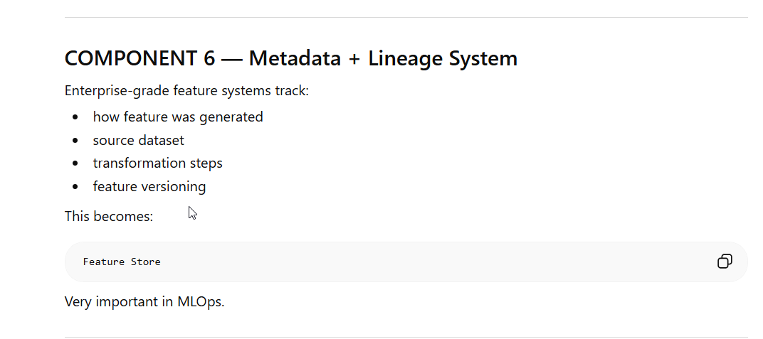
- Now based on detected data, recommend models automatically for classification, regression, clustering, object detection, segmentation as per the need.

